future.film.education Online-Teacher-Training Course-Planner

This template is a document for your own notes when planning your online lessons.

First of all: Which priority do I want to set?

….

Do you want to focus on online tools or develop your content?
In general, we follow in this course the paradigm that the tools should follow the content: First the content -> then the technical tools. But that's just to give you an impulse to think about what you want to achieve in the course - and how :-)

Course Title

Fill in the course title you plan to work on in this course.
….

Not enough room? Use the space for notes at the end of this document.

Materials, training goals, didactic elements and media format
Please specify the title of the training materials and which training goals are addressed by them. Identify the didactic purpose (e.g., warm up, spark interest, teambuilding, motivation, develop competencies, ...) of the content and input plus the media you want to use. Remember "Bloom's Taxonomy” to specify your goals (see next page).

Kind of material | Goals | Didactic | Media/Content

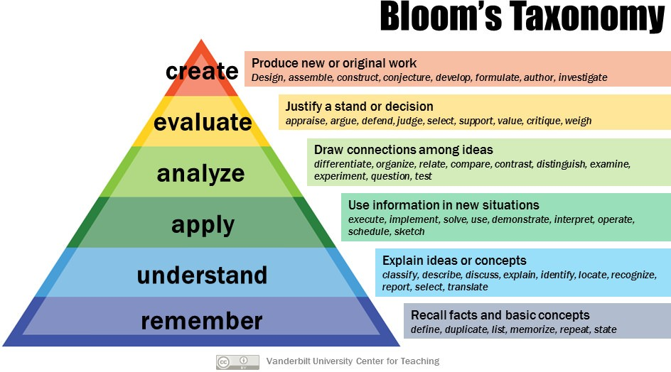

Reference: https://cft.vanderbilt.edu/guides-sub-pages/blooms-taxonomy/

If you want to note anything use this space:

Your time table for your course.

Fill in the agenda for your lesson and estimate the duration for working with the training materials

Time | Materials/Content | Trainers Tasks | Estimated Time

